CTP FINAL PROJECT REPORT


Project Title: Event Hive in AUW
Student 1 Details  Name: Fatima Attaie  ID: 242117  AUW Email: auw242117@auw.edu.bd |  | Student 2 Details  Name: Nisha Kumari  ID: 232030  AUW Email: nisha.kumari@auw.edu.bd
Student 3 Details
Name: Vadthita P. Amaral
ID: 242235
AUW Email: auw242235@auw.edu.bd

Date: 12th August 2026

Abstract
This project presents an interactive web-based event management platform titled "Event Hive." Developed using HTML5, CSS3, and modern JavaScript, the platform enables students and campus community members at Asian University for Women (AUW) to discover, filter, and book spots for various campus events, including workshops, auditions, and webinars. The objective of the project was to create a responsive, user-friendly, and state-driven web experience featured with a dynamic search engine, category and price filtering, live countdown timers, and seamless booking integration.

2. Introduction
Modern web applications rely heavily on intuitive navigation and real-time interactive elements. The primary goal of this project was to design and implement a centralized, browser-based campus event hub tailored for the Asian University for Women (AUW). Event Hive serves as a digital solution to streamline event management, allowing users to effortlessly explore upcoming academic and extracurricular activities, view event details, and reserve tickets in real time Objectives:
Key Technical & UI Features
- ​Dynamic Search & Filtering: Includes a search bar alongside category (e.g., Workshop, Audition, Webinar) and price drop-down filters for instant event discovery.
- ​Live Event Countdown: Real-time countdown timers on event cards indicating exact days, hours, and minutes remaining before an event begins.
- ​Ticket Booking System: Interactive "Book Ticket" functional buttons integrated directly into event listings (featuring both paid and free events).
- ​Responsive Layout: A clean, dark-themed user interface styled with modern UI components and fluid card grid layouts.

3. Methodology / Implementation
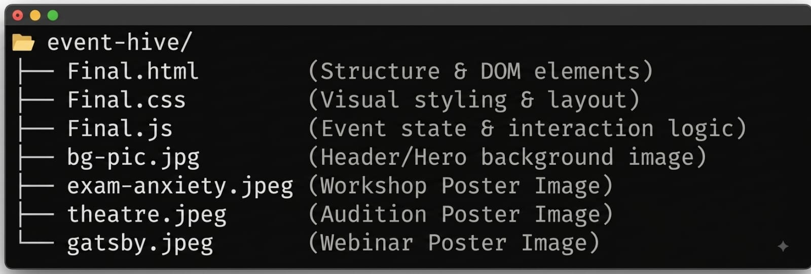
The project follows a standard three-tier client-side architecture:
System Architecture:
- ​HTML Structure (Final.html): Divided into a structured header and grid layout: a Navigation Bar (Logo & Navigation Links), a Hero Section (Search Bar & Filter Controls), and an Event Display Area (Dynamic Event Cards & Booking Controls).
- ​CSS Styling (Final.css): Built using CSS Grid and Flexbox. Features modern dark-mode aesthetic, card-hover transformations, responsive layouts, and overlay properties to maintain clear text legibility against dynamic visual backgrounds.

4. Results
Functional Event Platform: Successfully built a fully operational, responsive client-side web-application for managing and discovering campus events at AUW.
- Interactive Filtering & Search: Real-time dynamic filtering allows users to instantly search events by keywords, event categories (Workshops, Auditions, Webinars), and price ranges without page reloads.
- Live Countdown Timers: Dynamic JavaScript countdowns automatically compute and display remaining time for each upcoming event, improving user engagement.
- Integrated Booking System: Provided an intuitive UI flow for users to select events and reserve tickets directly through interactive button triggers.

5. Challenges and Limitations Challenges Faced:
- Dynamic DOM Manipulation: Synchronizing live countdown timers across multiple event cards simultaneously while maintaining smooth page performance.
- State & Filter Management: Combining search inputs with multiple dropdown filters (category and price) to ensure correct filtering results when multiple conditions are applied together.
- Responsive Layout Design: Structuring fluid CSS Grid and Flexbox layouts to ensure optimal displaying of media elements and text overlays across different screen sizes.

Limitations:
- Client-Side Storage Only: The application currently relies on local frontend state, meaning booking data and new event entries do not persist across session resets without a backend database.
- Static Event Data: Event details and initial availability are hardcoded in JavaScript rather than fetched dynamically from a live REST API or server.
- Simplified Payment/Reservation: The ticket booking mechanism serves as a front-end simulation without integrated payment gateway processing or user account authentication.

6. Conclusion and Discussion
The development of EventHive demonstrates the effectiveness of lightweight, client-side technologies (HTML5, CSS3, and modern JavaScript) in building fully interactive educational campus platforms. By leveraging dynamic DOM manipulation, the application successfully delivers real-time features—such as live event countdowns and multi-criteria search filtering—without relying on heavy external libraries or frameworks.

The EventHive project successfully achieves its objective of providing a responsive, user-friendly event discovery and booking platform for the Asian University for Women (AUW) community. Through clean component structuring, responsive CSS Grid layouts, and custom JavaScript interaction logic, the system streamlines how students locate workshops, auditions, and webinars. Overall, this project highlights the practical application of core web development fundamentals in solving real-world campus organization and communication challenges

8. References
- Duckett, J. (2014). JavaScript and JQuery: Interactive Front-End Web Development. John Wiley& Sons.
- ​Duckett, J. (2011). HTML and CSS: Design and Build Websites. John Wiley & Sons.
- Flanagan, D. (2020). JavaScript: The Definitive Guide (7th ed.). O'Reilly Media

9. Individual Contributions
- Fatima - HTML Structure & Layout Architecture
  - Responsibilities: ​ Designing the foundational document layout, defining semantic HTML tags, and setting up container divisions for the header, search/filter controls, and event grid views.
  - Code Implementation & Explanation: HTML Architecture: The structure relies on semantic elements (<input>, <select>, and <div> grids) that act as target hooks for JavaScript DOM queries and layout rendering.
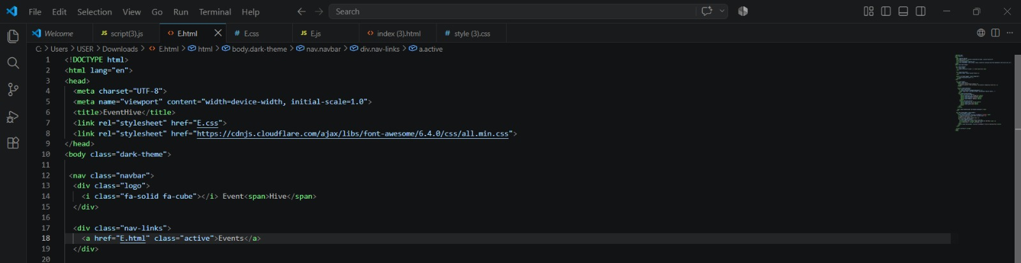

Explanation: The HTML sets up the basic structure of the website. It links external CSS stylesheets for styling and icon fonts, defines the main navigation bar with a logo (EventHive), and creates the header links to help users easily navigate through the page.
- Nisha- CSS Styling, Layout & Visual Design
  - Responsibilities: Implementing a cohesive dark-mode theme, defining typography, designing hover effects, and using CSS Grid/Flexbox to create responsive card layouts across devices.
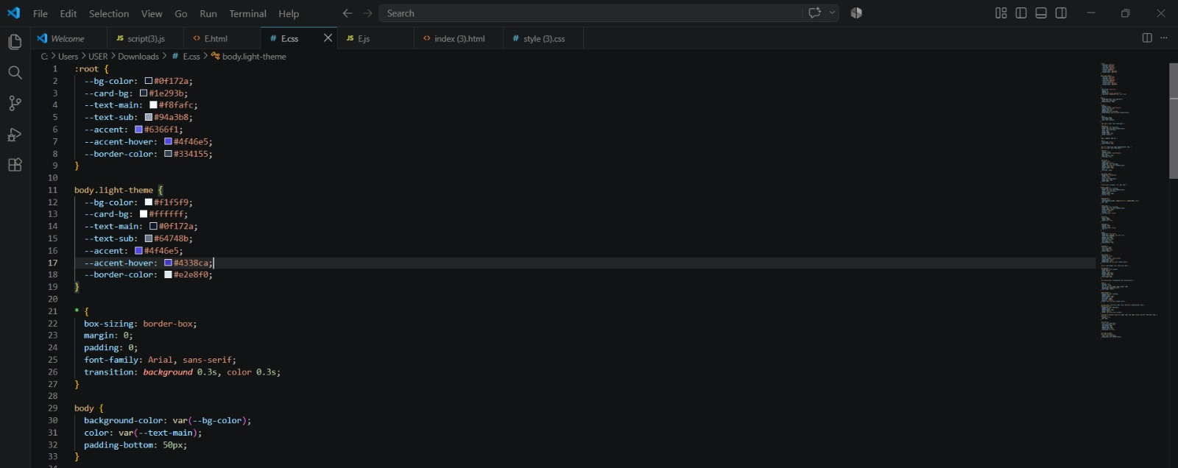
  - Code Implementation & Explanation: Uses CSS Grid (grid-template-columns: repeat(auto-fit, ...)) to ensure event cards wrap seamlessly depending on screen resolution. Hover transforms provide visual feedback when interacting with cards.

Explanation: The CSS defines custom color variables for dark and light themes, sets up base styling rules like font families and margins, and controls layout spacing. This ensures the website maintains a smooth background transition and consistent text colors across different themes.

- Vadthita - JavaScript Development & Logic Implementation
  - Responsibilities: Writing DOM manipulation logic, integrating event listener controls for live search and filtering, and creating real-time event countdown timers.
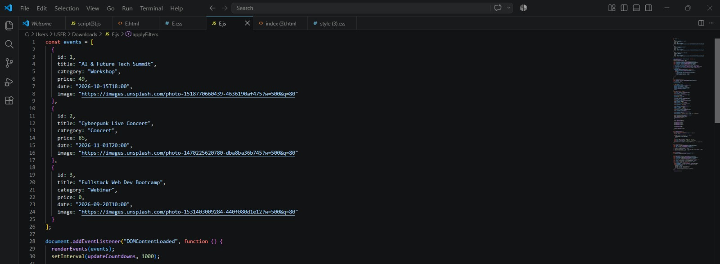
  - Code Implementation & Explanation: Countdown Calculation: Computes the difference between the target date (dataset.date) and the current system time using standard Unix timestamp math.

Explanation: The JavaScript script creates an array of event objects storing key details—such as title, category, price, date, and image URLs. Once the page loads, it automatically renders these events dynamically onto the screen and sets up a timer interval to keep countdowns updated every second.

